**Implementation of Shortest Path Algorithms using Dijkstra’s Algorithm**

**INPUT:**

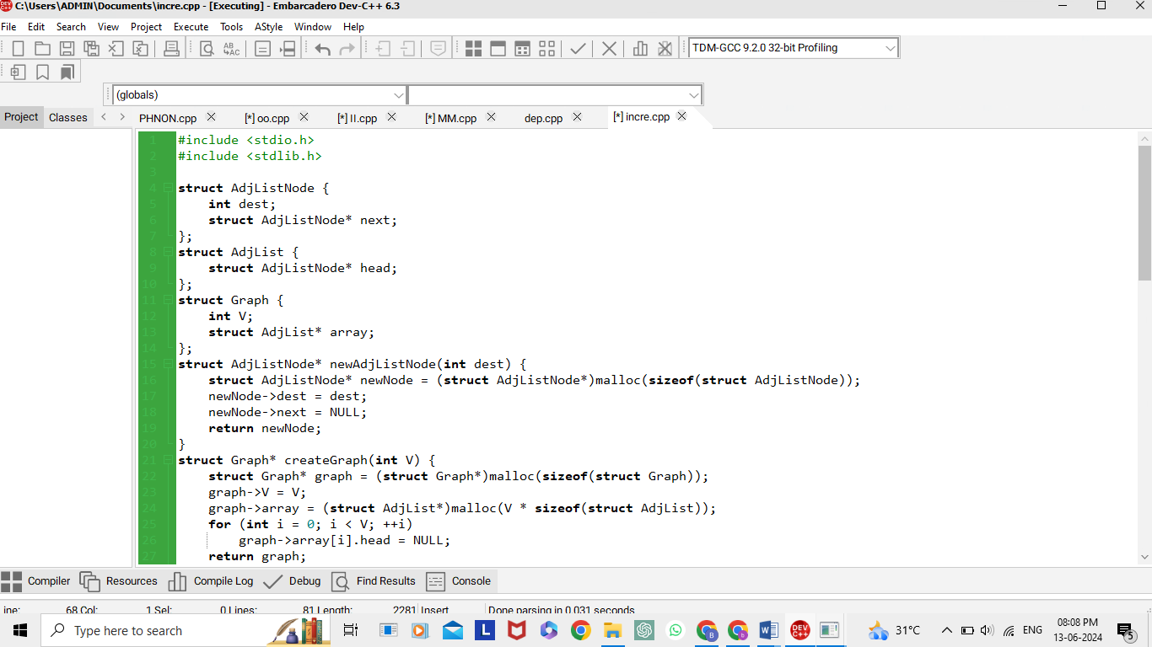

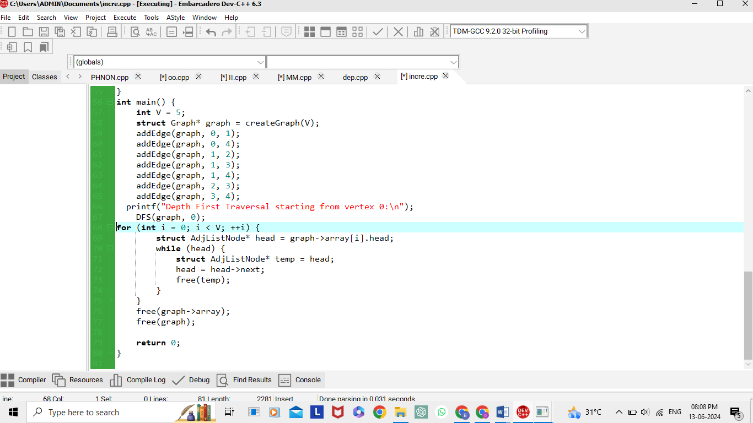

**OUTPUT:**

